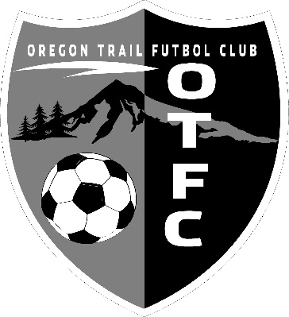
OTFC PDP/Classic Coaching Application

Name: _________________________________ Date: ___________________

Address: ____________________________________________________________

Home Phone: ___________________________ Cell:______________________

Email Address: _______________________________________________________

Please list 2 previous coach references and 1 personal reference (Name, Number, Club/Relation):
- _____________________________________________________________________________
- _____________________________________________________________________________
- _____________________________________________________________________________

Please list below your coaching experience (including ages, gender, leagues). Playing experience will be taken into consideration in-lieu of coaching experience.

Current Coaches License: _________________
If you do not have a coaching license what is your plan to get a coaching license clinic this year? _______________________________________________________________________________
_______________________________________________________________________________

Which age group(s) are you interested in coaching? Boys / Girls

PDP: 2013 (U8) 2012 (U9) 2011 (U8)

Classic: 2010(U11) 2009(U12) 2008(U13) 2007(U14)

2006(U15) 2005(U16) 2004(U17) 2003 (U18)

Specialty Coach: Goalie Striker Defense Skills

What position are you interested in: (Please indicate your first and second choices if applicable)

Head Coach ________ Assistant Coach ________ Team Manager ________

What is your coaching philosophy? _____________________________________________
__________________________________________________________________________
__________________________________________________________________________
__________________________________________________________________________
__________________________________________________________________________
__________________________________________________________________________
__________________________________________________________________________
__________________________________________________________________________
Completion of this form does not guarantee that a coaching or team manager position will be available.

Please submit completed application along with references to: info@oregontrailfutbol.org

